**Docker Technical Blog**

**1 . What is Docker?**

Docker is a software platform that allows you to build, test, and deploy applications quickly. Docker packages software into standardized units called [containers](https://aws.amazon.com/containers/) that have everything the software needs to run including libraries, system tools, code, and runtime. Using Docker, you can quickly deploy and scale applications into any environment and know your code will run.

**2. How does Docker Works?**

Docker works by providing a standard way to run your code. Docker is an operating system for containers. Similar to how a [virtual machine](https://aws.amazon.com/ec2/) virtualizes (removes the need to directly manage) server hardware, containers virtualize the operating system of a server. Docker is installed on each server and provides simple commands you can use to build, start, or stop containers.

**3.Docker architecture:**

Docker uses a client-server architecture. The Docker *client* talks to the Docker *daemon*, which does the heavy lifting of building, running, and distributing your Docker containers. The Docker client and daemon *can* run on the same system, or you can connect a Docker client to a remote Docker daemon. The Docker client and daemon communicate using a REST API, over UNIX sockets or a network interface.

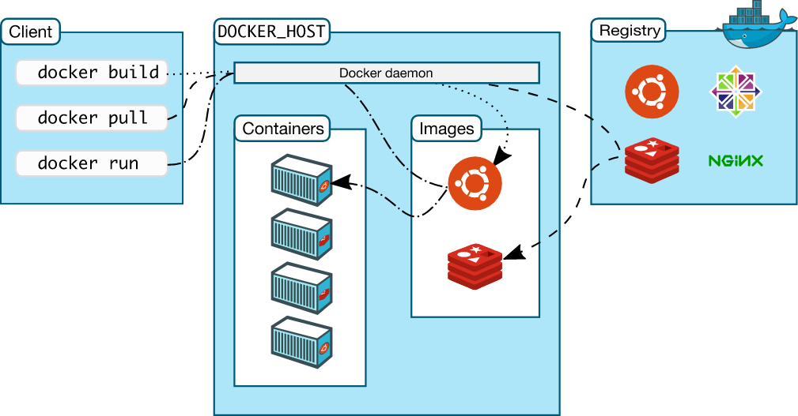

### **The Docker daemon**

The Docker daemon listens for Docker API requests and manages Docker objects such as images, containers, networks, and volumes. A daemon can also communicate with other daemons to manage Docker services.

**The Docker client**

The Docker client (docker) is the primary way that many Docker users interact with Docker. When you use commands such as docker run, the client sends these commands to docked, which carries them out.

**Docker Desktop**

Docker Desktop is an easy-to-install application for your Mac or Windows environment that enables you to build and share containerized applications and microservices.

**Docker registries**

A Docker *registry* stores Docker images. Docker Hub is a public registry that anyone can use, and Docker is configured to look for images on Docker Hub by default. You can even run your own private registry.

### **Docker objects**

When you use Docker, you are creating and using images, containers, networks, volumes, plugins, and other objects. This section is a brief overview of some of those objects.